Hemisphere
# Source: AI Source: Provided by: [Data Path: Persons Table -> ID Column: 1, Name_En Column: Motasem Essam] -> From: [ChatGPT] on [7/25/2026]
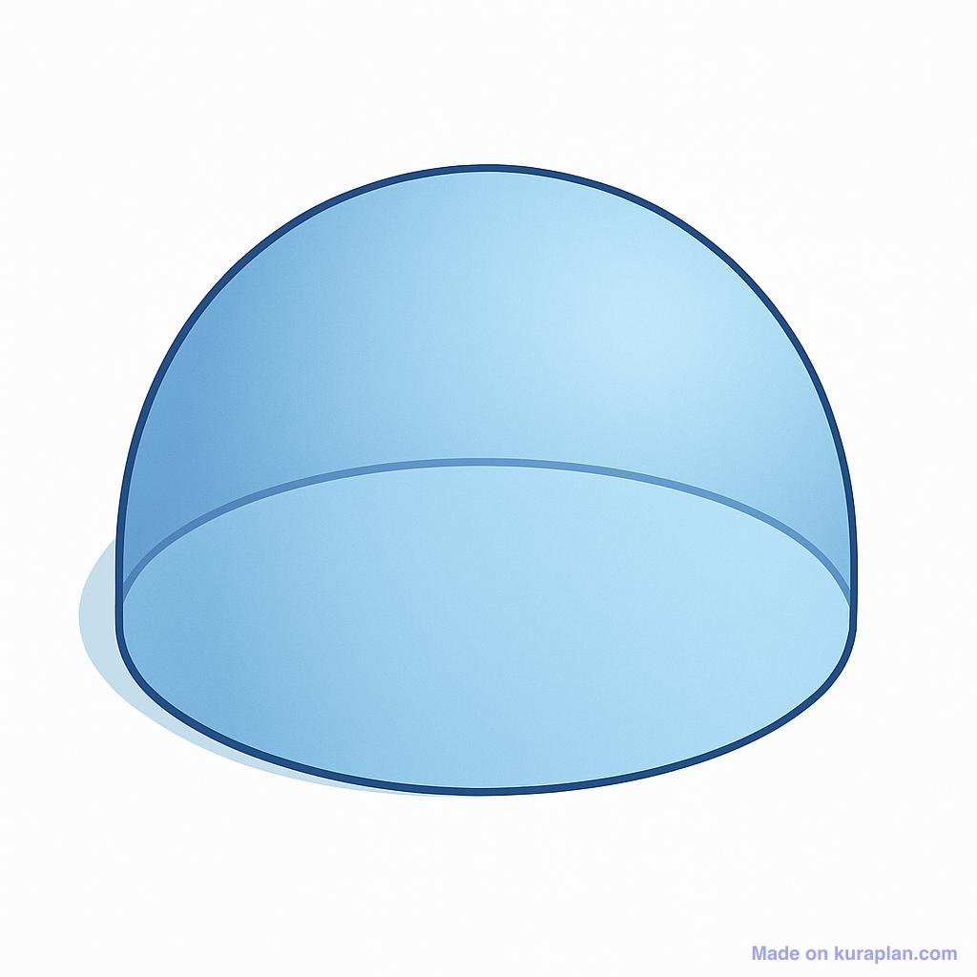
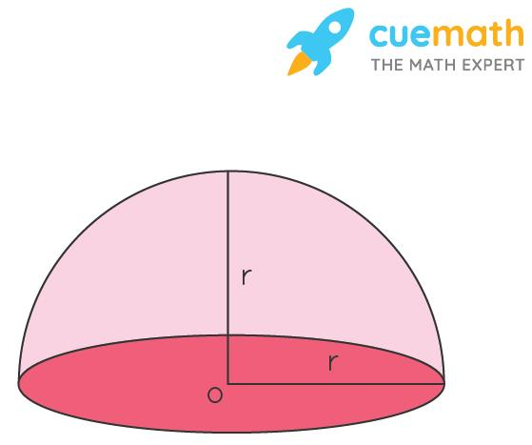
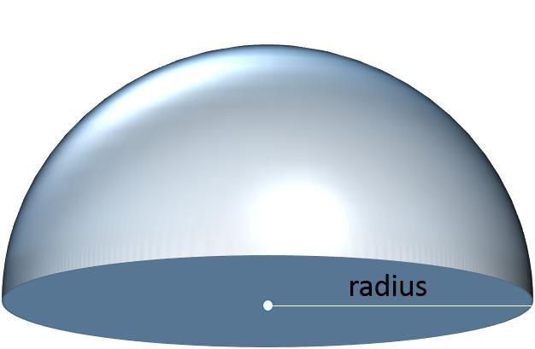

Definition
# Source: AI Source: Provided by: [Data Path: Persons Table -> ID Column: 1, Name_En Column: Motasem Essam] -> From: [ChatGPT] on [7/25/2026]
A hemisphere is a three-dimensional solid formed by dividing a sphere into two equal halves using a plane that passes through the sphere's center. Each half consists of a curved hemispherical surface and a flat circular base.
A hemisphere has the same radius as the original sphere and represents exactly half of the sphere's volume.

Simple Definition
# Source: AI Source: Provided by: [Data Path: Persons Table -> ID Column: 1, Name_En Column: Motasem Essam] -> From: [ChatGPT] on [7/25/2026]
A hemisphere is half of a sphere, like a bowl turned upside down or the dome of a building when modeled as half a sphere.

Types of Hemispheres

Upper Hemisphere
# Source: AI Source: Provided by: [Data Path: Persons Table -> ID Column: 1, Name_En Column: Motasem Essam] -> From: [ChatGPT] on [7/25/2026]
The upper hemisphere is the half of a sphere lying above a plane through its center, when the sphere is oriented with a vertical axis.
- Has a curved upper surface.
- Has a flat circular base at the equatorial plane.
- Extends from the equatorial plane to the topmost point.

Lower Hemisphere
# Source: AI Source: Provided by: [Data Path: Persons Table -> ID Column: 1, Name_En Column: Motasem Essam] -> From: [ChatGPT] on [7/25/2026]
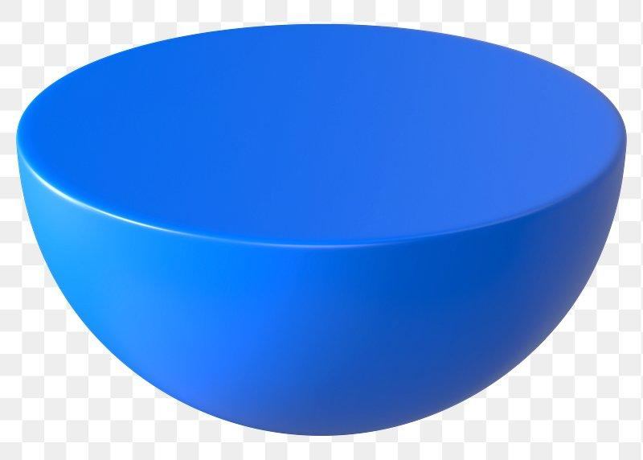
The lower hemisphere is the half lying below the central dividing plane.
- Has a curved lower surface.
- Has a flat circular base at the equatorial plane.
- Extends from the equatorial plane to the bottommost point.

Solid Hemisphere and Hemispherical Surface

Solid Hemisphere
# Source: AI Source: Provided by: [Data Path: Persons Table -> ID Column: 1, Name_En Column: Motasem Essam] -> From: [ChatGPT] on [7/25/2026]
The three-dimensional region enclosed by the curved surface and circular base, including its interior.
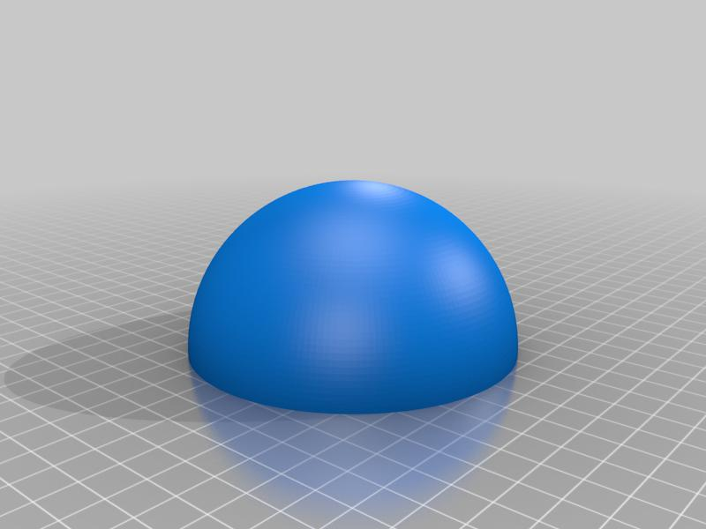

Hemispherical Surface
# Source: AI Source: Provided by: [Data Path: Persons Table -> ID Column: 1, Name_En Column: Motasem Essam] -> From: [ChatGPT] on [7/25/2026]
The curved boundary alone, excluding the flat circular base and the interior.
Note: Upper and lower hemispheres describe orientation. A solid hemisphere and a hemispherical surface differ in whether the enclosed volume is included.
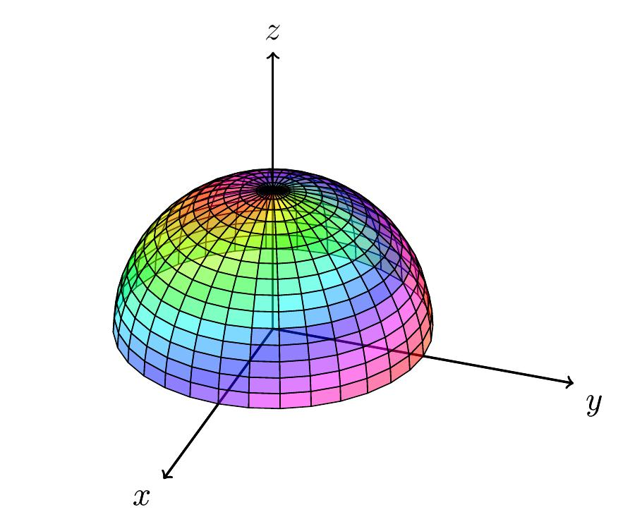

Key Characteristics
# Source: AI Source: Provided by: [Data Path: Persons Table -> ID Column: 1, Name_En Column: Motasem Essam] -> From: [ChatGPT] on [7/25/2026]
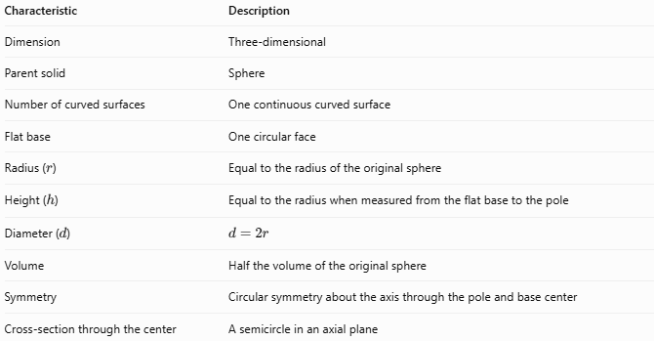
Characteristic | Description
Dimension | Three-dimensional
Parent solid | Sphere
Number of curved surfaces | One continuous curved surface
Flat base | One circular face
Radius ($r$) | Equal to the radius of the original sphere
Height ($h$) | Equal to the radius when measured from the flat base to the pole
Diameter ($d$) | $$d=2r$$
Volume | Half the volume of the original sphere
Symmetry | Circular symmetry about the axis through the pole and base center
Cross-section through the center | A semicircle in an axial plane

Geometric Components
# Source: AI Source: Provided by: [Data Path: Persons Table -> ID Column: 1, Name_En Column: Motasem Essam] -> From: [ChatGPT] on [7/25/2026]
- Curved surface: The rounded part inherited from the sphere.
- Circular base: The flat disk created by the central cut.
- Center ($O$): The center of the original sphere, located at the center of the circular base.
- Radius ($r$): Distance from the center to any point on the sphere's surface.
- Diameter ($d$): Distance across the circular base through its center.
- Pole: The highest or lowest point of the hemisphere, depending on its orientation.
- Height ($h$): Perpendicular distance between the circular base and the pole; $h=r$.

Mathematical Representations and Formulas
# Source: AI Source: Provided by: [Data Path: Persons Table -> ID Column: 1, Name_En Column: Motasem Essam] -> From: [ChatGPT] on [7/25/2026]
Let $r$ be the radius of the hemisphere.

Diameter
# Source: AI Source: Provided by: [Data Path: Persons Table -> ID Column: 1, Name_En Column: Motasem Essam] -> From: [ChatGPT] on [7/25/2026]
$$\boxed{d=2r}$$

Base Area
# Source: AI Source: Provided by: [Data Path: Persons Table -> ID Column: 1, Name_En Column: Motasem Essam] -> From: [ChatGPT] on [7/25/2026]
The flat circular base has area:
$$\boxed{A_{B}=πr^{2}}$$

Curved Surface Area
# Source: AI Source: Provided by: [Data Path: Persons Table -> ID Column: 1, Name_En Column: Motasem Essam] -> From: [ChatGPT] on [7/25/2026]
A hemisphere has half the curved surface area of a complete sphere.
Since a sphere has surface area $4πr^{2}$:
$$\boxed{A_{C}=2πr^{2}}$$

Total Surface Area
# Source: AI Source: Provided by: [Data Path: Persons Table -> ID Column: 1, Name_En Column: Motasem Essam] -> From: [ChatGPT] on [7/25/2026]
For a solid hemisphere including its flat circular base, add the curved area and base area:
$$A_{T}=2πr^{2}+πr^{2}$$
Therefore:
$$\boxed{A_{T}=3πr^{2}}$$

Volume
# Source: AI Source: Provided by: [Data Path: Persons Table -> ID Column: 1, Name_En Column: Motasem Essam] -> From: [ChatGPT] on [7/25/2026]
A sphere has volume:
$$V_{\text{sphere}}=\frac{4}{3}πr^{3}$$
A hemisphere is half of that volume:
$$V_{\text{hemisphere}}=\frac{1}{2}\left(\frac{4}{3}πr^{3}\right)$$
Therefore:
$$\boxed{V=\frac{2}{3}πr^{3}}$$

Relationship Between Height and Radius
# Source: AI Source: Provided by: [Data Path: Persons Table -> ID Column: 1, Name_En Column: Motasem Essam] -> From: [ChatGPT] on [7/25/2026]
For a hemisphere:
$$\boxed{h=r}$$
Thus, its volume can also be expressed as:
$$V=\frac{2}{3}{πh}^{3}$$

Worked Examples
# Source: AI Source: Provided by: [Data Path: Persons Table -> ID Column: 1, Name_En Column: Motasem Essam] -> From: [ChatGPT] on [7/25/2026]
Example 1: Calculate the Volume
A solid hemisphere has radius $r=6\text{ cm}$. Find its volume.
Solution
$$V=\frac{2}{3}πr^{3}$$
$$V=\frac{2}{3}π{\left(6\right)}^{3}$$
$$V=\frac{2}{3}π\left(216\right)$$
$$\boxed{V=144π{\text{ cm}}^{3}≈452.39{\text{ cm}}^{3}}$$
Example 2: Calculate the Curved Surface Area
A hemisphere has radius $r=5\text{ cm}$. Find its curved surface area.
Solution
$$A_{C}=2πr^{2}$$
$$A_{C}=2π{\left(5\right)}^{2}$$
$$\boxed{A_{C}=50π{\text{ cm}}^{2}≈157.08{\text{ cm}}^{2}}$$
Example 3: Calculate the Total Surface Area
A solid hemisphere has radius $r=4\text{ cm}$. Find its total surface area, including the flat base.
Solution
$$A_{T}=3πr^{2}$$
$$A_{T}=3π{\left(4\right)}^{2}$$
$$\boxed{A_{T}=48π{\text{ cm}}^{2}≈150.80{\text{ cm}}^{2}}$$
Example 4: Calculate the Radius from the Diameter
A hemisphere has a base diameter of $14\text{ cm}$. Find its radius and height.
Solution
$$r=\frac{d}{2}=\frac{14}{2}=7\text{ cm}$$
Since the height equals the radius:
$$\boxed{r=7\text{ cm}, h=7\text{ cm}}$$

Constructing a Hemisphere

Geometric Instruments
# Source: AI Source: Provided by: [Data Path: Persons Table -> ID Column: 1, Name_En Column: Motasem Essam] -> From: [ChatGPT] on [7/25/2026]
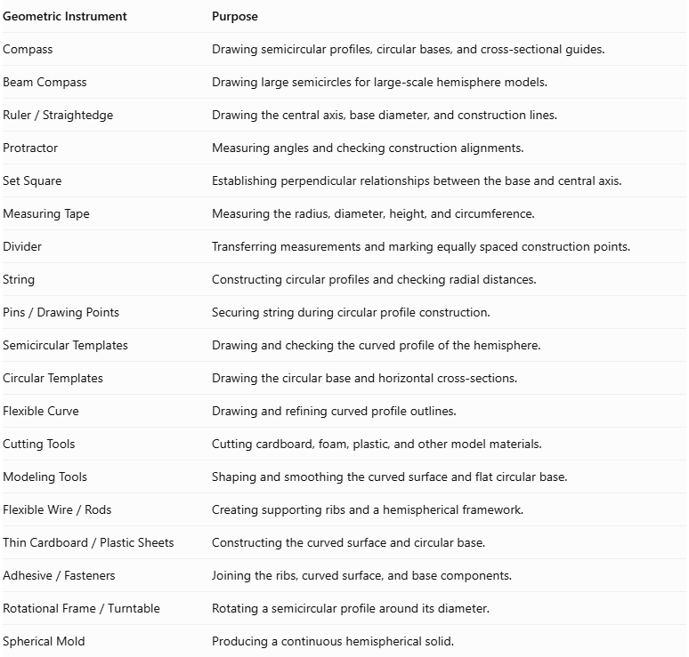
Geometric Instrument | Purpose
Compass | Drawing semicircular profiles, circular bases, and cross-sectional guides.
Beam Compass | Drawing large semicircles for large-scale hemisphere models.
$$Ruler/Straightedge$$ | Drawing the central axis, base diameter, and construction lines.
Protractor | Measuring angles and checking construction alignments.
Set Square | Establishing perpendicular relationships between the base and central axis.
Measuring Tape | Measuring the radius, diameter, height, and circumference.
Divider | Transferring measurements and marking equally spaced construction points.
String | Constructing circular profiles and checking radial distances.
$$Pins/DrawingPoints$$ | Securing string during circular profile construction.
Semicircular Templates | Drawing and checking the curved profile of the hemisphere.
Circular Templates | Drawing the circular base and horizontal cross-sections.
Flexible Curve | Drawing and refining curved profile outlines.
Cutting Tools | Cutting cardboard, foam, plastic, and other model materials.
Modeling Tools | Shaping and smoothing the curved surface and flat circular base.
$$FlexibleWire/Rods$$ | Creating supporting ribs and a hemispherical framework.
$$ThinCardboard/PlasticSheets$$ | Constructing the curved surface and circular base.
$$Adhesive/Fasteners$$ | Joining the ribs, curved surface, and base components.
$$RotationalFrame/Turntable$$ | Rotating a semicircular profile around its diameter.
Spherical Mold | Producing a continuous hemispherical solid.
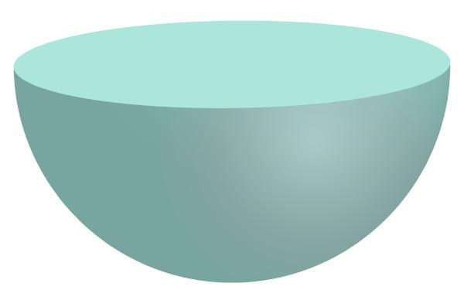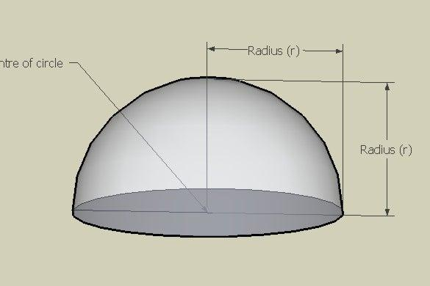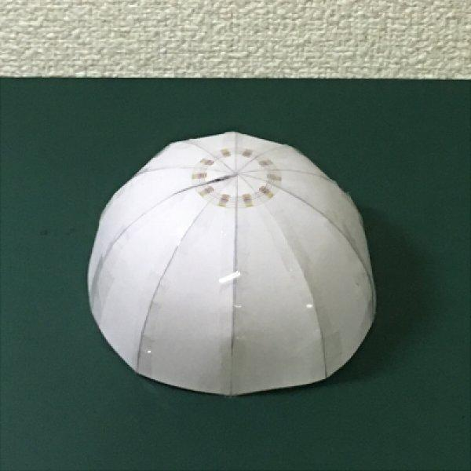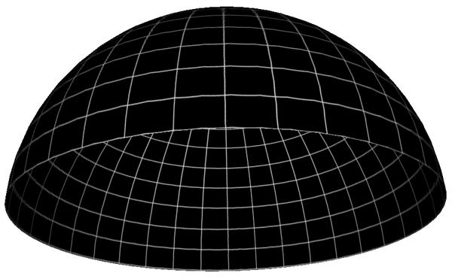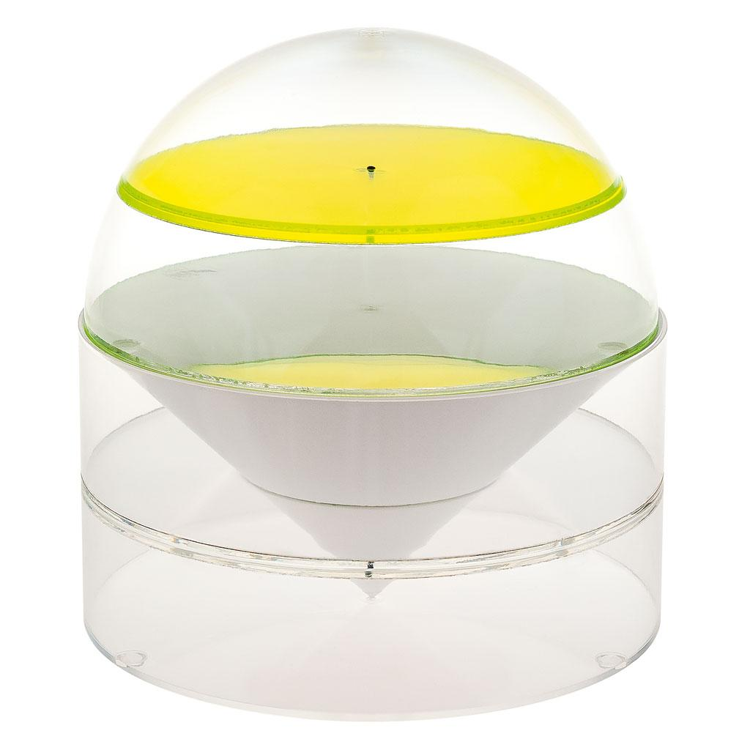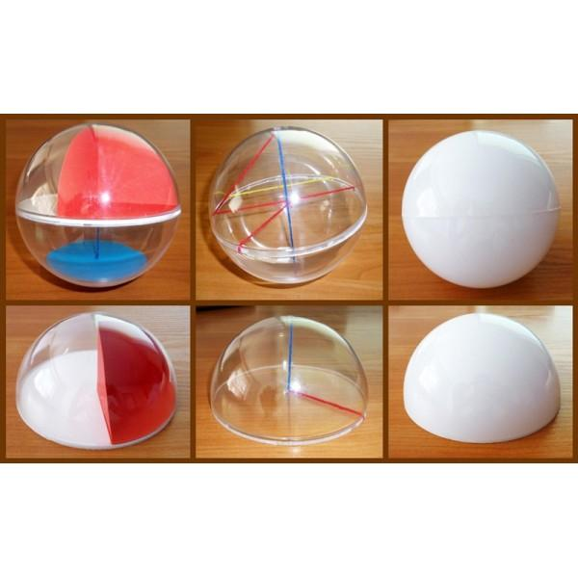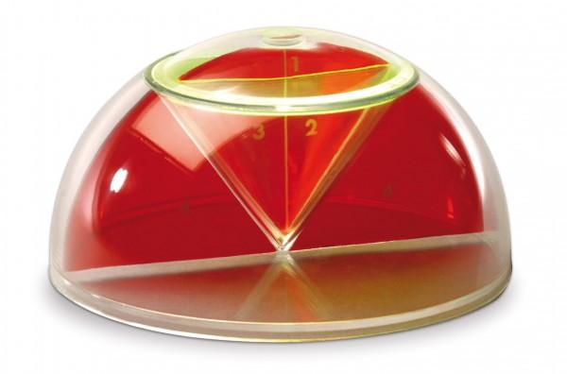

Instrument-Based Construction Procedures

Construction by Cutting a Complete Sphere
# Source: AI Source: Provided by: [Data Path: Persons Table -> ID Column: 1, Name_En Column: Motasem Essam] -> From: [ChatGPT] on [7/25/2026]
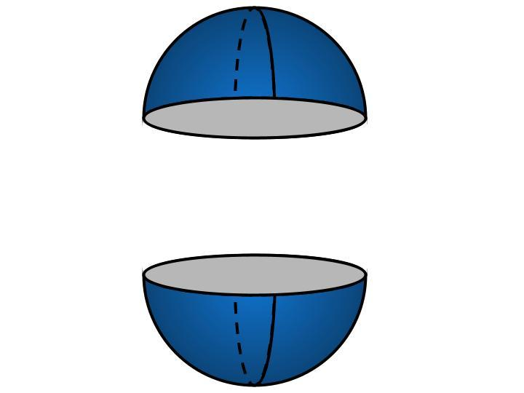
- Construct a complete sphere using modeling clay, foam, plaster, or another suitable material.
- Mark the center of the sphere using a ruler and measuring tools.
- Draw a great-circle reference line around the sphere to identify the intended cutting plane.
- Ensure that the cutting plane passes through the center of the sphere.
- Position the sphere securely on a stable cutting surface.
- Cut the sphere along the marked great-circle plane.
- Separate the two equal halves carefully.
- Select one half as the required hemisphere.
- Smooth the newly exposed circular base.
- Check that the curved surface and flat base meet along the same circular boundary.
This method produces two equal hemispheres from one complete sphere.

Construction by Rotating a Quarter-Circular Profile
# Source: AI Source: Provided by: [Data Path: Persons Table -> ID Column: 1, Name_En Column: Motasem Essam] -> From: [ChatGPT] on [7/25/2026]
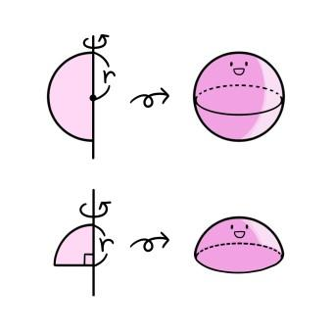
- Draw a horizontal baseline representing the radius of the hemisphere's circular base.
- Mark one endpoint as the center of the base.
- Set the compass to the required radius.
- Draw a quarter-circle connecting the two perpendicular radius endpoints.
- Draw the second radius perpendicular to the baseline.
- Cut out the quarter-circular profile or transfer it onto a suitable rigid material.
- Attach the profile to a rotational frame, aligning one radius with the rotation axis.
- Rotate the quarter-circular region through ${360}^{°}$.
- Use the resulting shape as a guide for forming the hemispherical solid.
- Smooth the curved surface and check the circular base.
Rotating a quarter-disc around one of its radii generates a solid hemisphere.

Construction Using Circular Cross-Sections
# Source: AI Source: Provided by: [Data Path: Persons Table -> ID Column: 1, Name_En Column: Motasem Essam] -> From: [ChatGPT] on [7/25/2026]
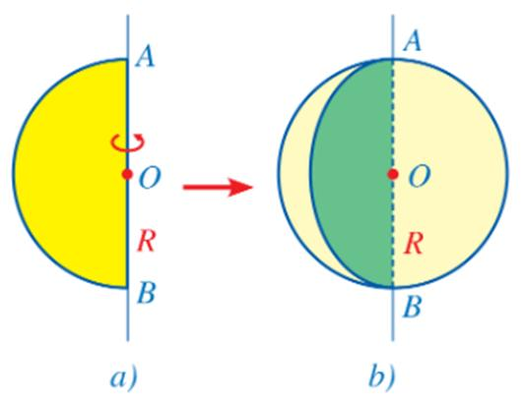
- Draw a circle representing the flat base of the hemisphere.
- Mark its center using a ruler and divider.
- Draw a perpendicular central axis through the center.
- Mark the required hemisphere height, equal to the base radius.
- Divide the height into several equal intervals.
- Determine the radius of the circular section at each height.
- Draw the corresponding circles using a compass or circular templates.
- Cut the circles from cardboard, foam, or thin plastic.
- Arrange the circular sections perpendicular to the central axis.
- Connect their outer boundaries using flexible strips or modeling material.
- Smooth the connections to form a continuous hemispherical surface.
- Finish the bottom circular face.
For a hemisphere of radius $R$, the radius of a horizontal cross-section at height $h$, measured from the flat base, is:
$$r=\sqrt{R^{2}-h^{2}}$$
This method produces an approximation of the curved surface. More cross-sections improve its smoothness.

Construction Using a Semicircular Template
# Source: AI Source: Provided by: [Data Path: Persons Table -> ID Column: 1, Name_En Column: Motasem Essam] -> From: [ChatGPT] on [7/25/2026]
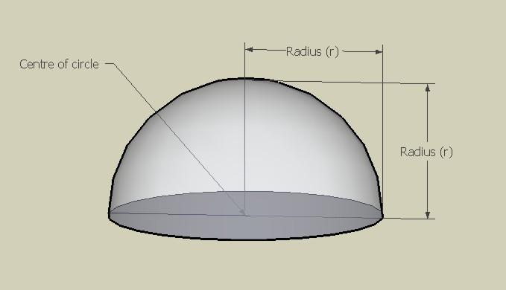
- Draw a vertical diameter using a ruler.
- Mark its midpoint as the center of the intended hemisphere.
- Set the compass to the required radius.
- Draw a semicircle using the diameter as its straight boundary.
- Cut the semicircular profile from cardboard or thin plastic.
- Prepare a circular base with a diameter equal to the semicircle's diameter.
- Position the semicircular template vertically through the center of the base.
- Use the template to check the curved profile while shaping clay, foam, or another material.
- Rotate the template around the central axis to check the curvature from different directions.
- Smooth the surface until it follows the semicircular profile.
- Refine the flat circular base.
This method is particularly useful for checking the symmetry and curvature of a hemisphere.

Construction Using a Rotational Wire-Frame Structure
# Source: AI Source: Provided by: [Data Path: Persons Table -> ID Column: 1, Name_En Column: Motasem Essam] -> From: [ChatGPT] on [7/25/2026]
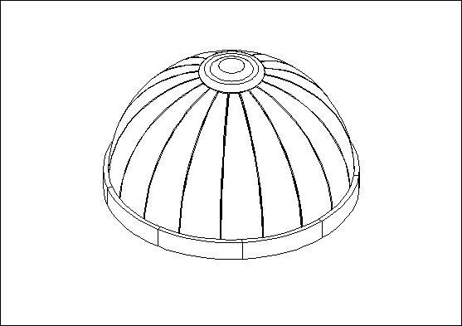
- Draw the circular base using a compass.
- Cut a circular supporting ring from wire or lightweight material.
- Mark equally spaced points around the ring.
- Prepare a central upper support point representing the top of the hemisphere.
- Cut flexible wires or rods to the required lengths.
- Attach one end of each wire to the circular base.
- Bend the wires upward toward the central upper point.
- Secure the upper ends together.
- Add intermediate circular supporting rings if required.
- Check the symmetry of the curved framework.
- Cover the framework with a flexible sheet if a closed surface is required.
- Secure the connections and refine the model.
This method creates an open hemispherical framework or a supporting structure for a closed model.

Construction Using Modeling Clay
# Source: AI Source: Provided by: [Data Path: Persons Table -> ID Column: 1, Name_En Column: Motasem Essam] -> From: [ChatGPT] on [7/25/2026]
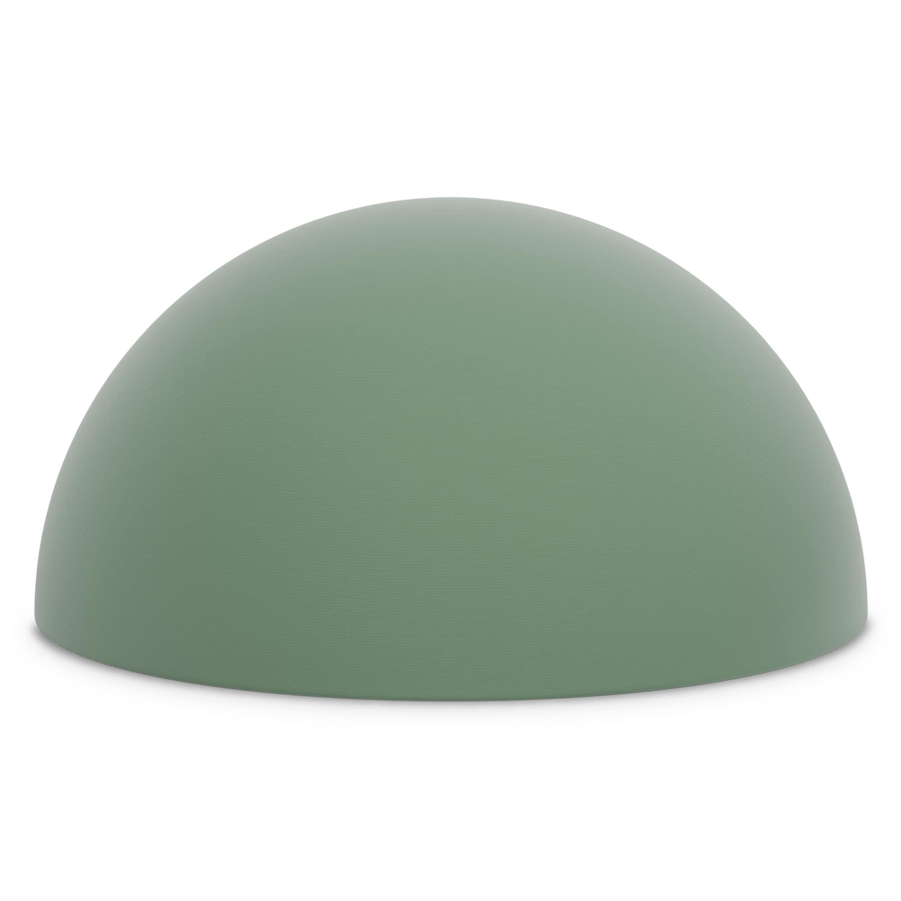
- Prepare a quantity of modeling clay.
- Draw a circle representing the required base.
- Form a clay mass slightly larger than the intended hemisphere.
- Flatten its bottom face to form a circular base.
- Mark the center of the base.
- Shape the upper portion into a dome using modeling tools.
- Use a semicircular template to check the curved profile.
- Rotate the template around the central axis to check the shape from different directions.
- Remove excess clay and smooth the curved surface.
- Refine the circular base to ensure it is flat.
- Measure the base radius and hemisphere height.
- Inspect the completed model for symmetry.
This method is suitable for producing a solid hemisphere without assembling separate components.

Construction Using a Spherical Mold
# Source: AI Source: Provided by: [Data Path: Persons Table -> ID Column: 1, Name_En Column: Motasem Essam] -> From: [ChatGPT] on [7/25/2026]
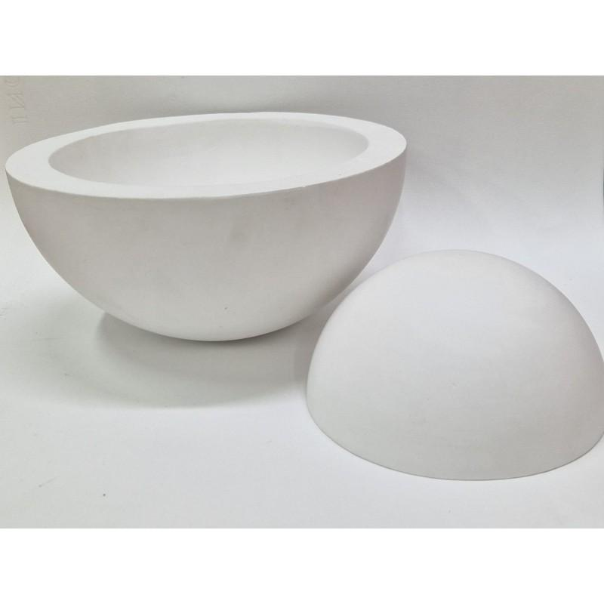
- Determine the required radius of the hemisphere.
- Prepare a spherical mold with the required internal diameter.
- Mark or identify the plane passing through the mold's center.
- Configure the mold to produce one half of the sphere.
- Verify the circular base dimensions.
- Apply a suitable release material if necessary.
- Pour plaster, resin, or another suitable modeling material into the mold.
- Allow the material to set or cure completely.
- Remove the formed hemisphere carefully.
- Trim excess material around the circular boundary.
- Smooth the curved surface and flat base.
- Inspect the finished model against the required dimensions.
This method is suitable for producing repeated hemispherical models.

Construction Using a Paper or Cardboard Model
# Source: AI Source: Provided by: [Data Path: Persons Table -> ID Column: 1, Name_En Column: Motasem Essam] -> From: [ChatGPT] on [7/25/2026]
- Draw a circle representing the required base.
- Divide the circle into several equal angular sections using a protractor.
- Draw the corresponding meridian profiles using a semicircular template.
- Divide each profile into equal intervals.
- Transfer the measurements onto thin cardboard.
- Cut out the required curved panels.
- Curve the panels gradually to follow the hemispherical shape.
- Join the panels along their edges using adhesive.
- Attach the panels to the circular base.
- Add internal supporting strips if necessary.
- Smooth the joining edges.
- Allow the adhesive to dry and inspect the finished model.
This method creates a lightweight educational representation. The curved surface is approximated by joined panels.

Geometric Construction Notes
# Source: AI Source: Provided by: [Data Path: Persons Table -> ID Column: 1, Name_En Column: Motasem Essam] -> From: [ChatGPT] on [7/25/2026]

Main geometric characteristics
# Source: AI Source: Provided by: [Data Path: Persons Table -> ID Column: 1, Name_En Column: Motasem Essam] -> From: [ChatGPT] on [7/25/2026]
- Hemisphere: One half of a sphere divided by a plane passing through its center.
- Circular Base: The flat face formed by the cutting plane.
- Curved Surface: The hemispherical portion of the original spherical surface.
- Radius: The distance from the sphere's center to any point on its surface.
- Height: Equal to the radius of the hemisphere.
- Great Circle: The circular boundary formed by the central cutting plane.

Supporting formulas
# Source: AI Source: Provided by: [Data Path: Persons Table -> ID Column: 1, Name_En Column: Motasem Essam] -> From: [ChatGPT] on [7/25/2026]
VOLUME
$$V=\frac{2}{3}πR^{3}$$
CURVED SURFACE AREA
$$A_{c}=2πR^{2}$$
BASE AREA
$$A_{b}=πR^{2}$$
TOTAL SURFACE AREA
$$A_{t}=3πR^{2}$$
HEIGHT
$$H=R$$
Where $R$ is the radius of the original sphere.

Main Hemisphere Variants
# Source: AI Source: Provided by: [Data Path: Persons Table -> ID Column: 1, Name_En Column: Motasem Essam] -> From: [ChatGPT] on [7/25/2026]
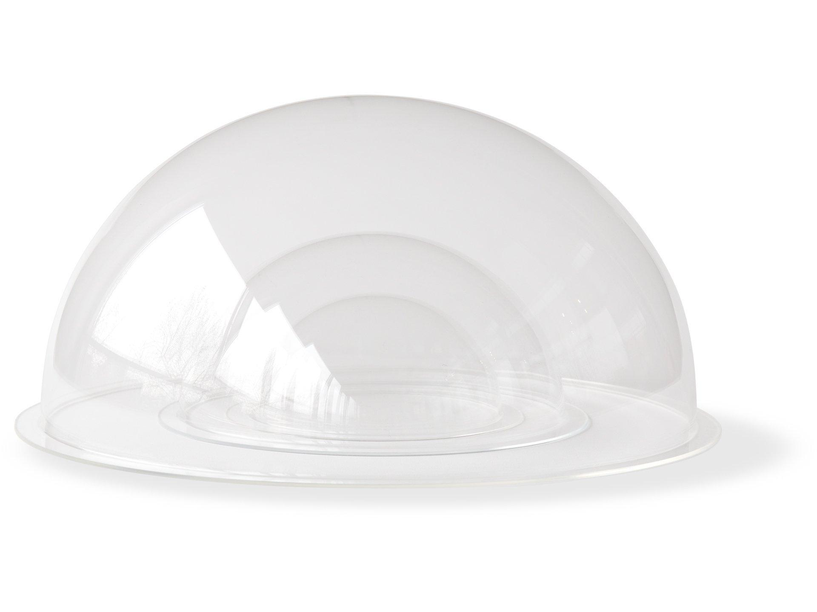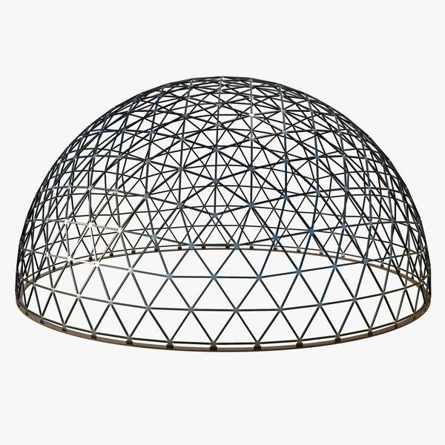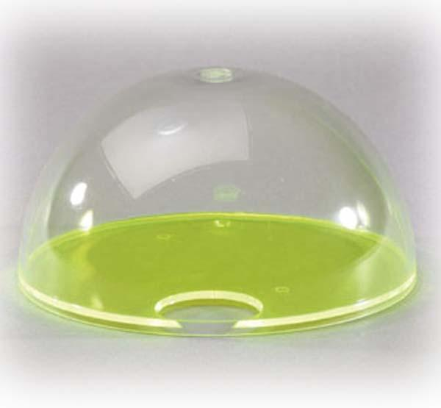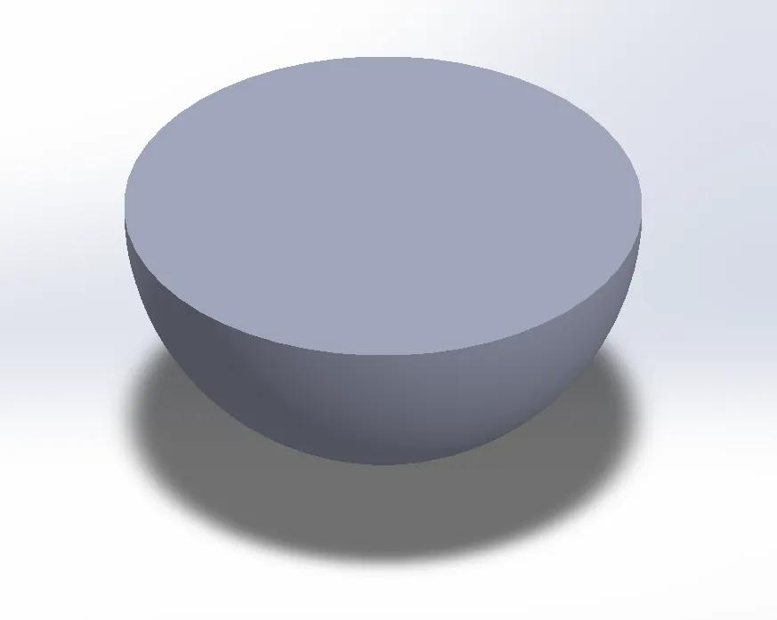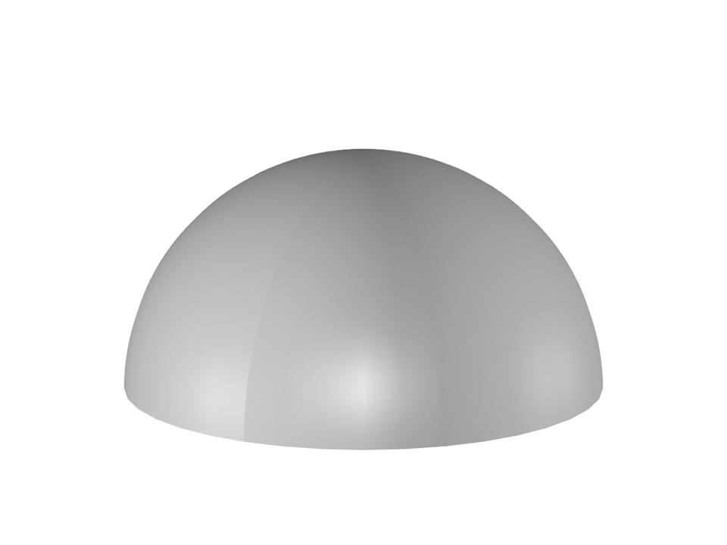
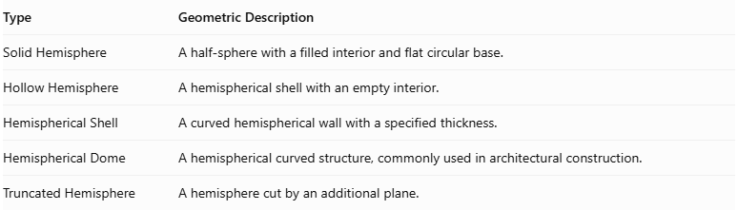
Type | Geometric Description
Solid Hemisphere | A half-sphere with a filled interior and flat circular base.
Hollow Hemisphere | A hemispherical shell with an empty interior.
Hemispherical Shell | A curved hemispherical wall with a specified thickness.
Hemispherical Dome | A hemispherical curved structure, commonly used in architectural construction.
Truncated Hemisphere | A hemisphere cut by an additional plane.
Construction Note: These procedures use physical geometric instruments, semicircular profiles, circular cross-sections, rotational mechanisms, molds, and surface construction. They do not use coordinate-based construction.
Reference Sources:
- The Construction and Principal Uses of Mathematical Instruments – Generation of a Sphere
- Mathematics and Physics – Spherical Geometry
- Engineering Drawing – Hemisphere and Spherical Surface Construction

Comparison with Related Solids
# Source: AI Source: Provided by: [Data Path: Persons Table -> ID Column: 1, Name_En Column: Motasem Essam] -> From: [ChatGPT] on [7/25/2026]
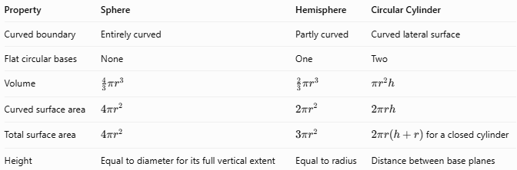
Property | Sphere | Hemisphere | Circular Cylinder
Curved boundary | Entirely curved | Partly curved | Curved lateral surface
Flat circular bases | None | One | Two
Volume | $$\frac{4}{3}{πr}^{3}$$ | $$\frac{2}{3}πr^{3}$$ | $$πr^{2}h$$
Curved surface area | $$4πr^{2}$$ | $$2πr^{2}$$ | $$2πrh$$
Total surface area | $$4πr^{2}$$ | $$3πr^{2}$$ | $2πr\left(h+r\right)$ for a closed cylinder
Height | Equal to diameter for its full vertical extent | Equal to radius | Distance between base planes

Applications
# Source: AI Source: Provided by: [Data Path: Persons Table -> ID Column: 1, Name_En Column: Motasem Essam] -> From: [ChatGPT] on [7/25/2026]
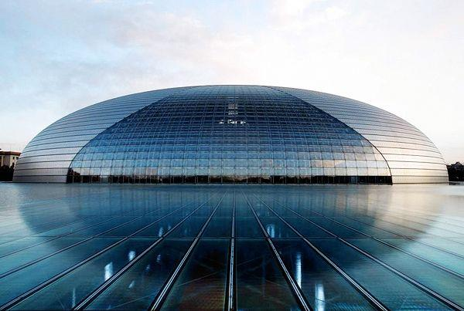
Architecture
Dome roofs and rounded structures are often modeled using hemispherical geometry.
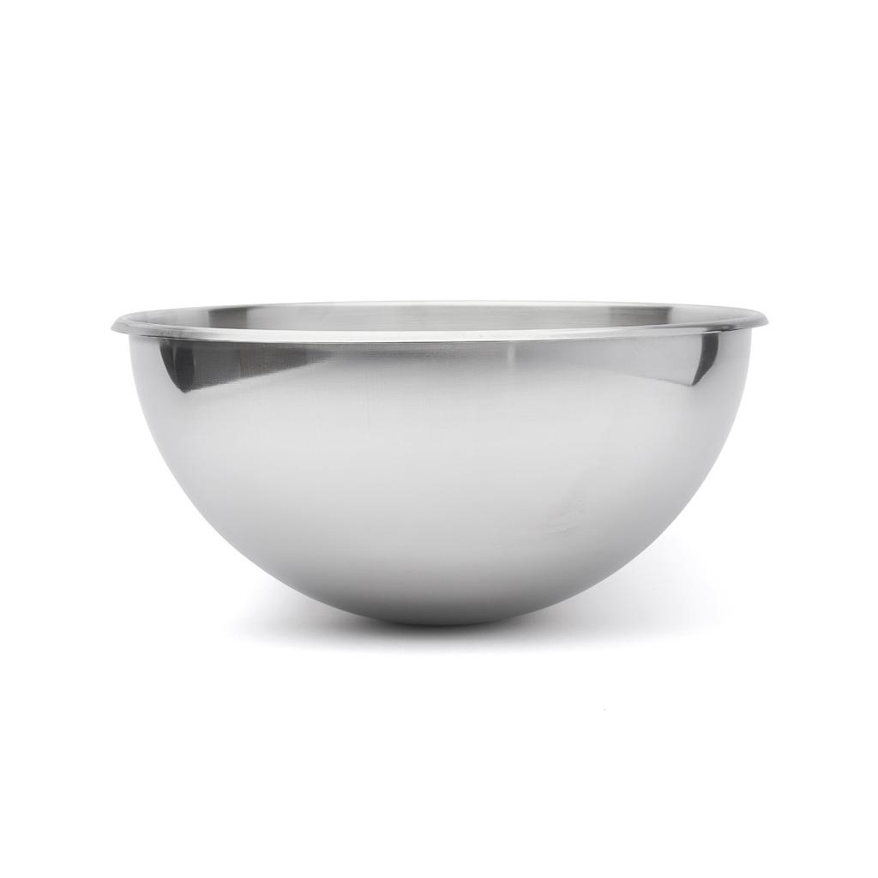
Containers and Bowls
Bowls and rounded vessels can approximate a hemispherical shape.
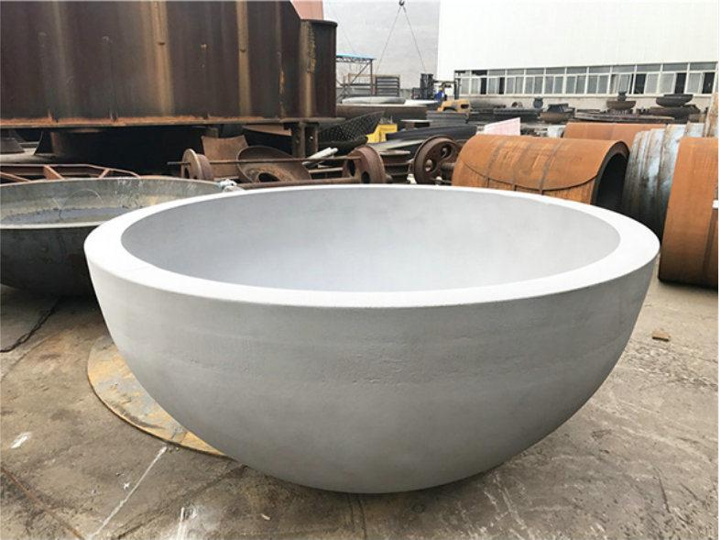
Engineering
Hemispherical end caps and pressure-vessel components use curved-surface geometry.
Mathematics and Education
Hemispheres help demonstrate cross-sections, volume relationships, and surface-area calculations.

Key Points
# Source: AI Source: Provided by: [Data Path: Persons Table -> ID Column: 1, Name_En Column: Motasem Essam] -> From: [ChatGPT] on [7/25/2026]
- A hemisphere is half of a sphere divided by a plane through its center.
- It has one curved surface and one flat circular base.
- Its height equals its radius.
- Its volume is $V=\frac{2}{3}πr^{3}$.
- Its curved surface area is $A_{C}=2πr^{2}$.
- Its total surface area, including the base, is $A_{T}=3πr^{2}$.
- Two equal hemispheres can form a sphere when joined along their circular bases.

Conclusion
# Source: AI Source: Provided by: [Data Path: Persons Table -> ID Column: 1, Name_En Column: Motasem Essam] -> From: [ChatGPT] on [7/25/2026]
A hemisphere is a three-dimensional solid formed by dividing a sphere through its center. It combines a curved hemispherical surface with a flat circular base. Its volume is half that of a sphere with the same radius, while its total surface area includes both the curved surface and the base. Hemispheres are important in geometry, architecture, engineering, and the design of rounded containers.

